Experiment 6

Draw the DFD to be considered while codding the individual processes or functions.

**0 level DFD**

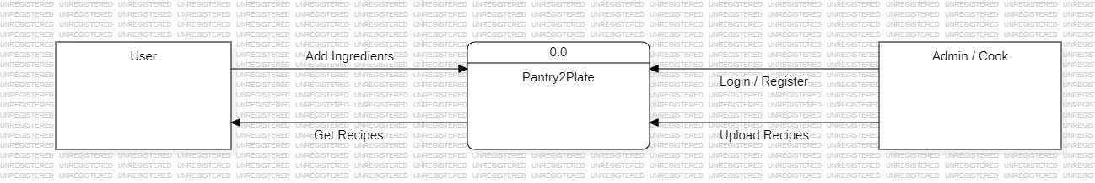

**1 level DFD**

